

Printable Name Tag Template Instructions
Use the following template to create and print name tags sized for 3.9" x 3.3", clear name tag holders. You can customize the name and role. For best results, print on cardstock and use a paper cutter for precise sizing.

Instructions
- Replace the sample information on each tag with the desired name and role.
- Print on 8.5 x 11 inch paper (standard US Letter), making sure your printer settings do not scale the document.
- Cut along the borders for individual name tags.

Tips for Making Changes to the template
- Before you are able to make changes to the template, you will need to click in the name box, bringing up a cursor, which indicates you can begin making changes.
- Use bold for names to increase visibility.
- For longer names, use a smaller font so that the entire name remains on one line.
This template was created for your typical 3.9" x 3.3" name tag printing needs, and a photo of what a finished name tag looks like is provided. These have been designed to make inserting these into name tag holders as easy as possible.
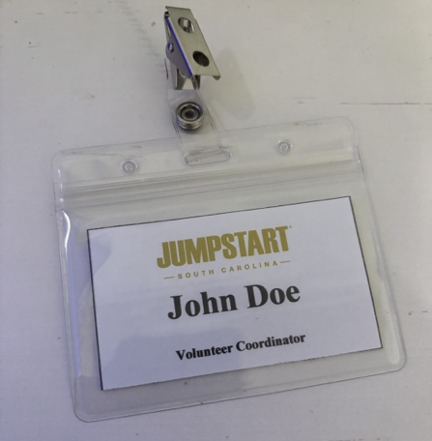


John Doe
Participant
John Doe
Participant
John Doe
Participant
John Doe
Table Leader
John Doe
Inside Leader
John Doe
Volunteer
Jane Doe
Volunteer Coordinator
John Doe
Regional Representative

